

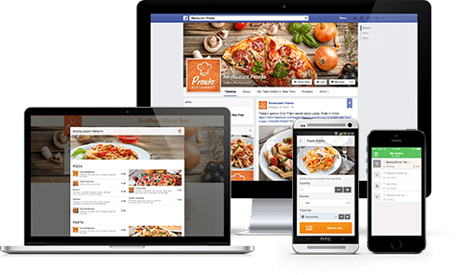
- Native apps for Android or iOS devices
- Optimized for smartphones and tablets
- Same real time-ordering as on web
- Pay food online, in-app
- Save my addresses

FoodBooking Club (free listing)
- Shared app with other restaurants
- Based on a curated list of restaurants
- Referring restaurant is shown first when its recommended clients start the app
Restaurant Branded App (optional)
- Only one restaurant brand with all its locations
- Personalized logo, slogan and background image

- Table reservation module for websites
- Table booking with ordering in advance options
- Reservations received and confirmed in real time with the order taking app
Table reservations
- Complete online ordering for websites
- Native ordering for mobile browsers
- Online ordering snap-in inside Facebook
- White-label design, suitable for any website
- Compatible with most website builders
Ordering apps for food clients
Food ordering for website and Facebook pages
Partner CompanyName Ltd
www.partnerwebsite.com
FirstName LastName
c: 0987640987
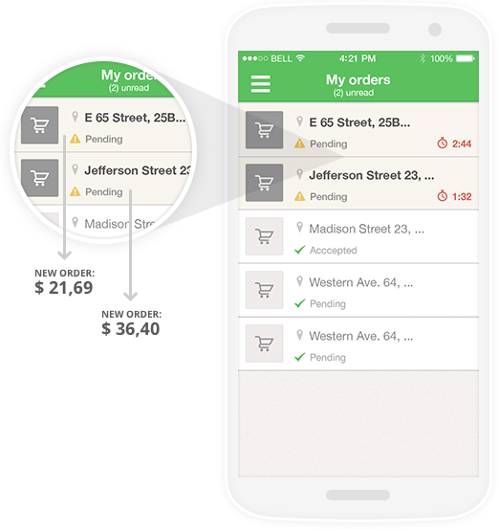
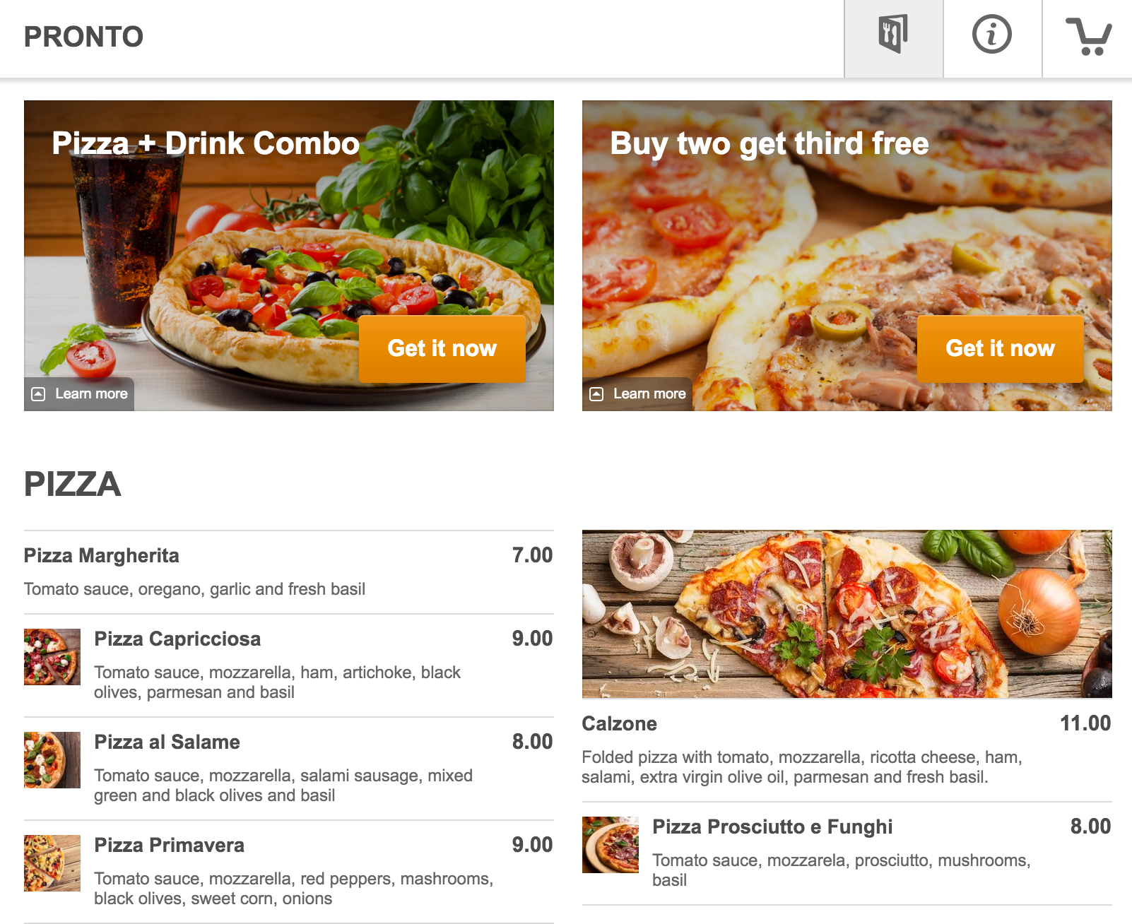
- Online payments, cash and other payment options
- Support for tips (on online payments)
- Sales optimized website builder
- Ordering stats, delivery heat-map, clients and orders lists (with data export)
- Promotions engine: 11 templates, coupons support, customers segmentation and targeting
- Multi-location support
- Works for pickup and delivery
- Multiple opening hours for delivery and pick-up
- Delivery zones settings with circles or polygons
- Minimum order and/or min delivery fee options
- Order for later with scheduled fulfilment
- Visual, drag & drop online menu editor
- Support for uploading own images, plus a generous collection of food images available to use
- Customizable food items: sizes, choices and add-ons with multiple select
- Support for promotions
- Restaurant app for receiving orders in real time
- Working from smartphones and tablets
- Available for Android and iOS
- Visual and audio notification on new order
- Easy review of customer and order details
- Real time confirmation of the order and fulfilment time
- Multiple Alerts when the ordering app is not reachable
- SMS auto-print support (iOS Only)
- Thermal Printing directly from the app (works with compliant Epson and Star models)
Online Menu
The most restaurant-friendly admin panel
Checkout
- Single page checkout
- Data auto-fill for returning customers
- Real time confirmation of the order
- Ready for promos with/without coupons
Orders taking app
Admin Panel
Online Ordering

